80% Vaccination Uptake

Population-wise projections

Cervical Cancer Incidence
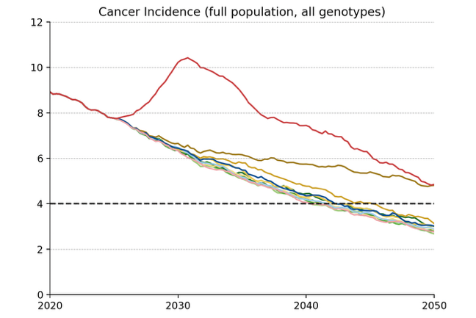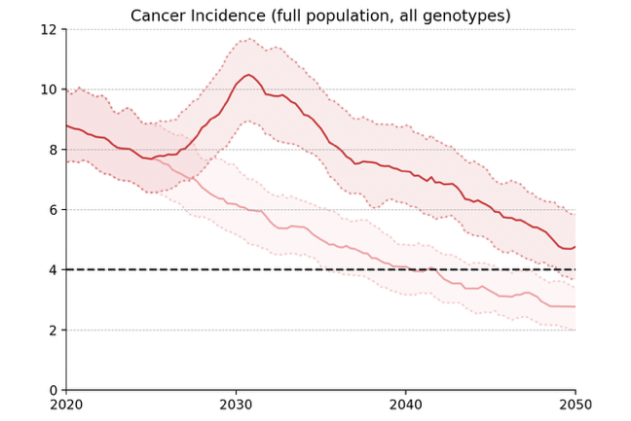
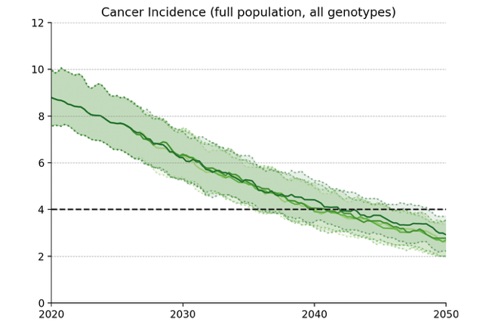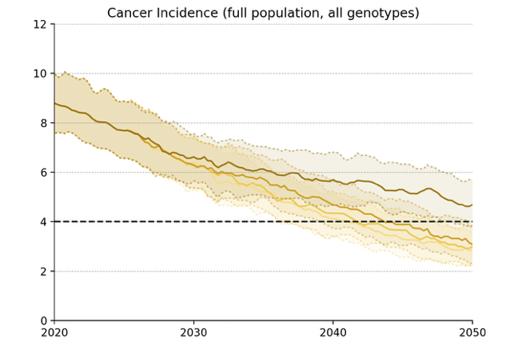
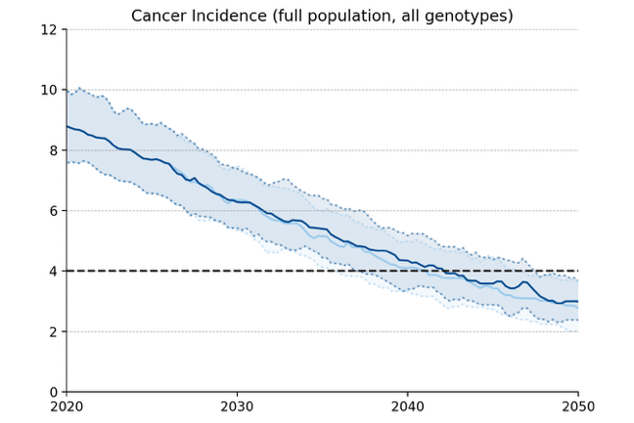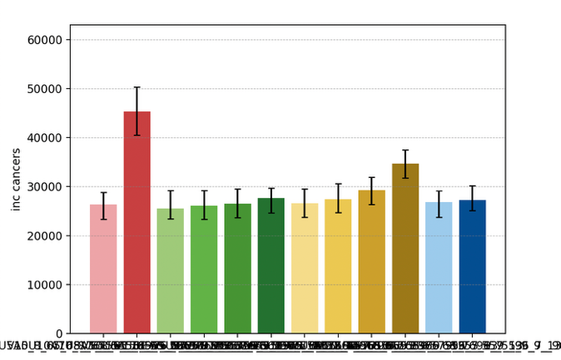
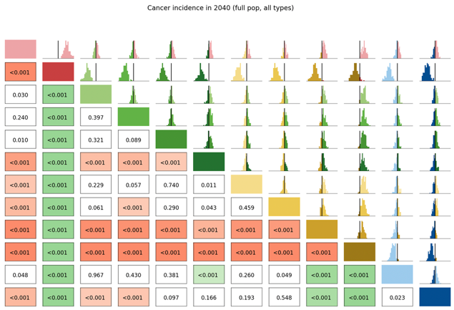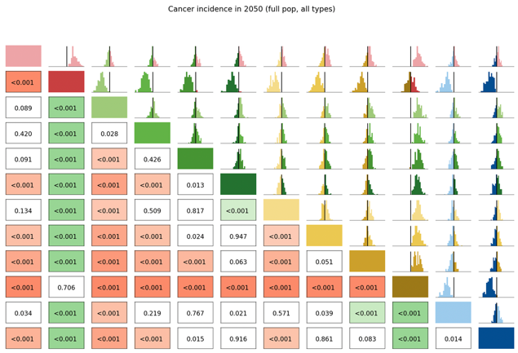

Long Term Undiagnosed Prevalence
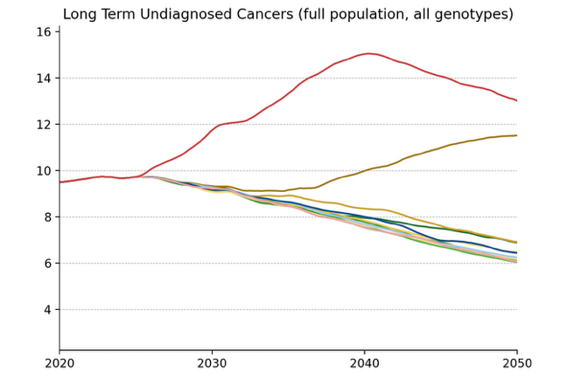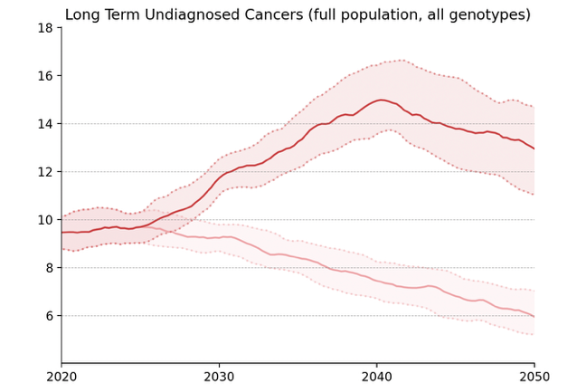
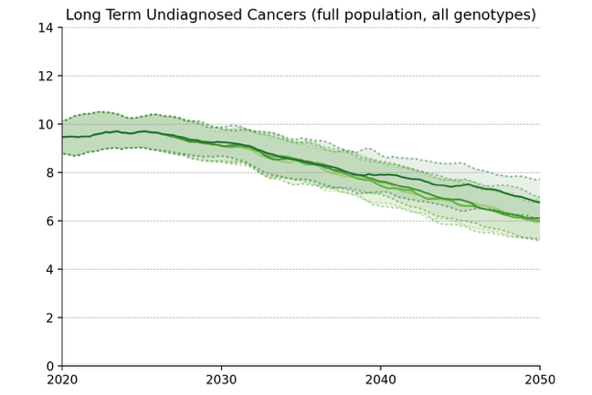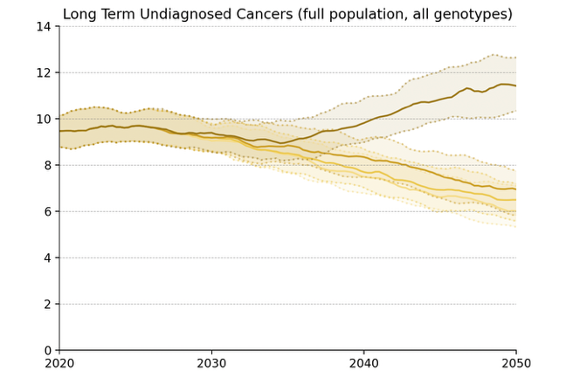
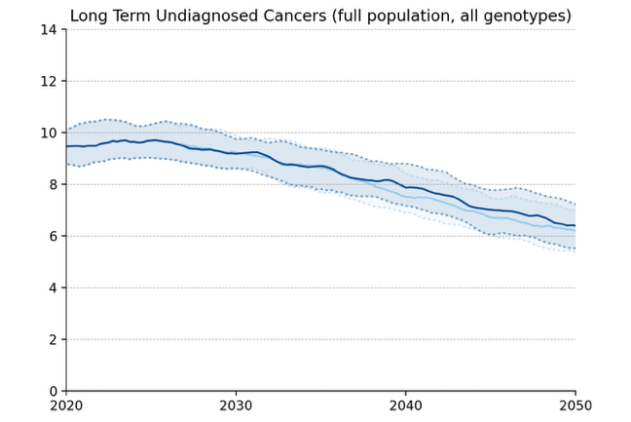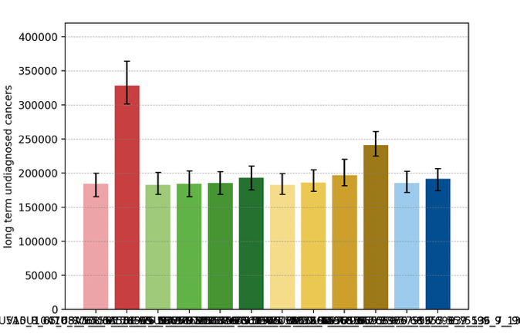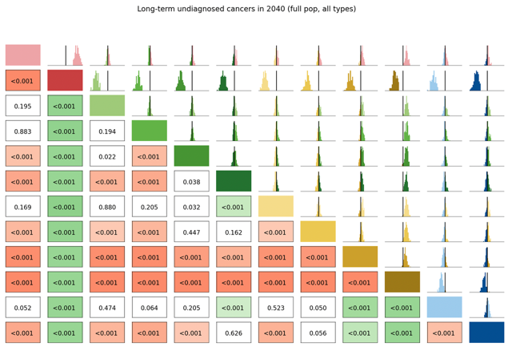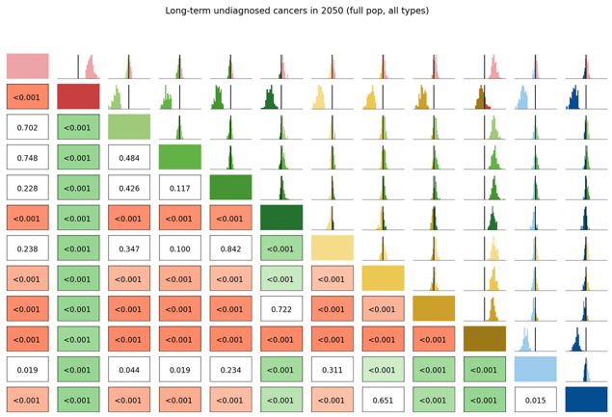

Number of Routine Screens
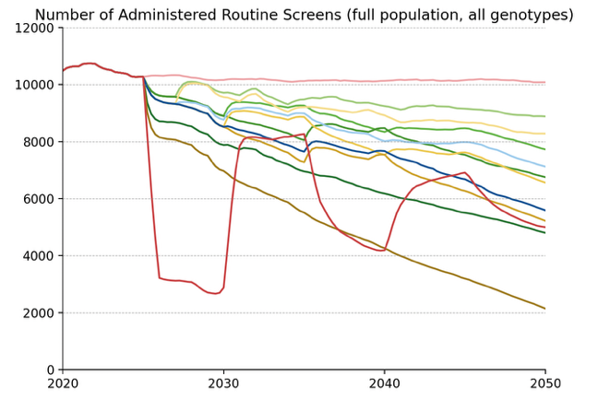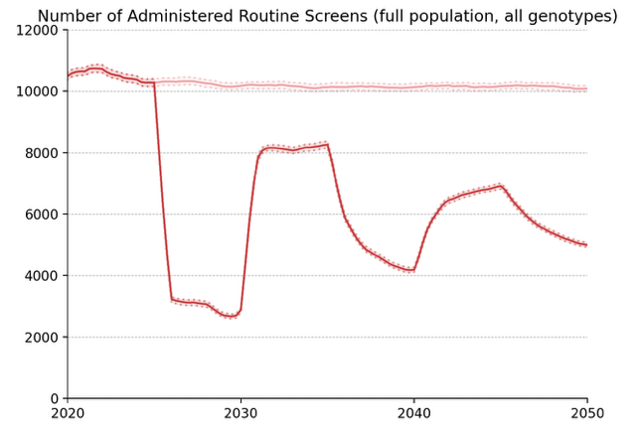
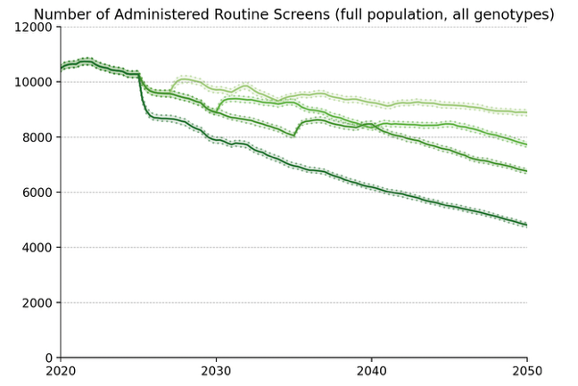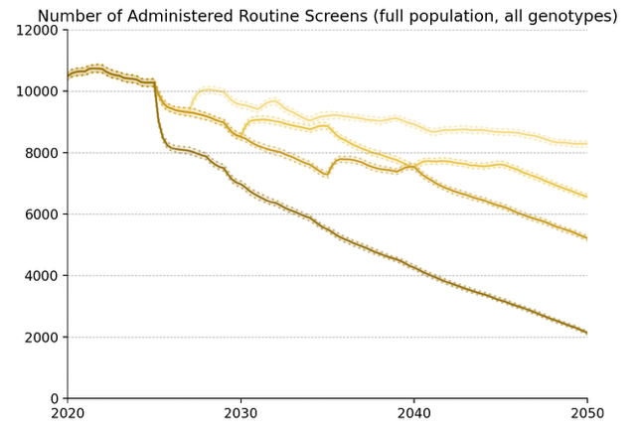
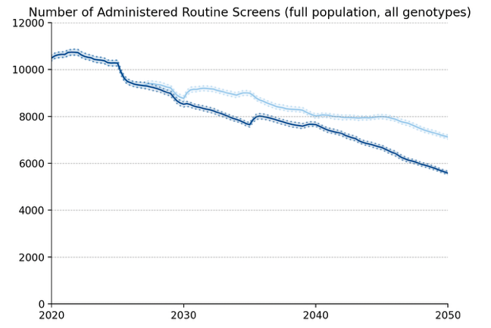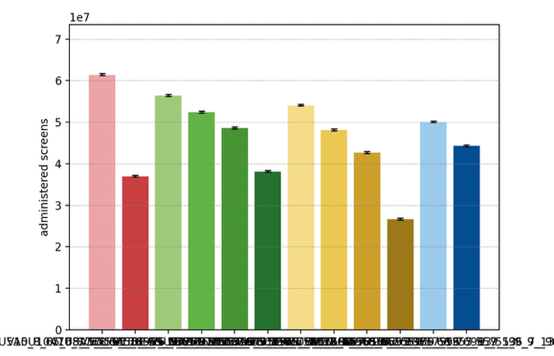

Average Number of Screens per Diagnosed Cancer, 2030-50
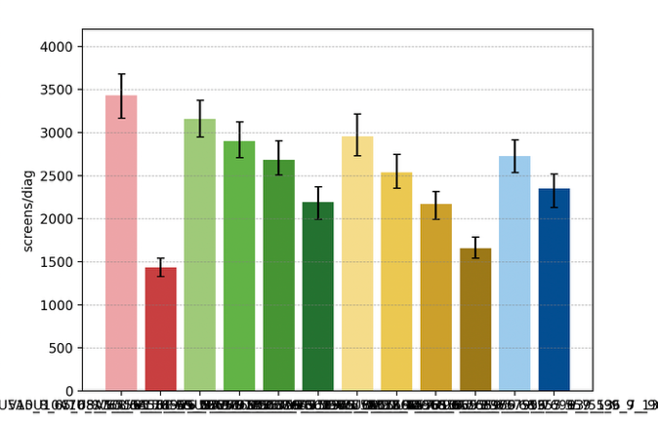

Elimination Probability Table
alg | Elimination Year: Median [LQ, UQ] (_8) | 2040.25 Elimination Probability (_8) | 2050.25 Elimination Probability (_8)
V5U5A5 | 2045 [2041, 2048] | 0.194 | 0.894
V7U5A5 | 2044 [2042, 2048] | 0.194 | 0.859
V10U5A5 | 2046 [2042, 2050] | 0.212 | 0.806
V15U5A5 | 2046 [2043, 2049] | 0.177 | 0.806
V_U5A5 | 2048 [2043, 2052] | 0.115 | 0.682
V7U7A5 | 2045 [2042, 2049] | 0.177 | 0.823
V10U10A5 | 2046 [2043, 2050] | 0.106 | 0.753
V15U15A5 | 2048 [2045, 2052] | 0.035 | 0.620
V_U_A5 | 2055 [2054, 2055] | 0.017 | 0.035
V10U7A5 | 2046 [2042, 2049] | 0.177 | 0.806
V15U10A5 | 2047 [2043, 2050] | 0.088 | 0.770
V10U10A10 | 2055 [2053, 2055] | 0.017 | 0.070
Maximum margin: 0.08947801227864008

Vaccinated Population projections

Cervical Cancer Incidence
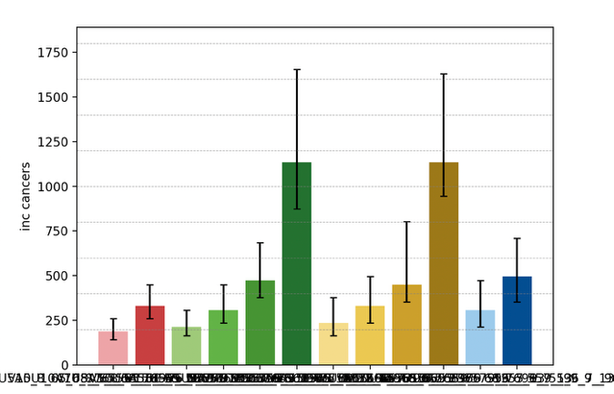
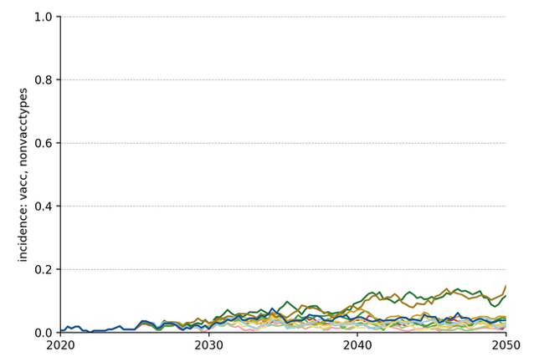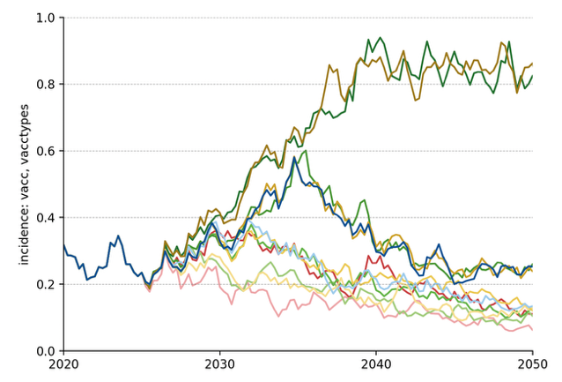
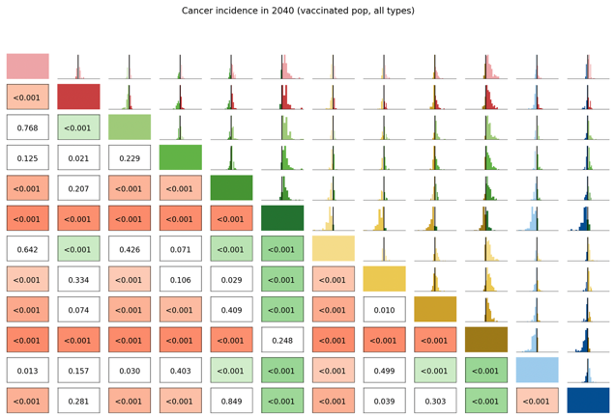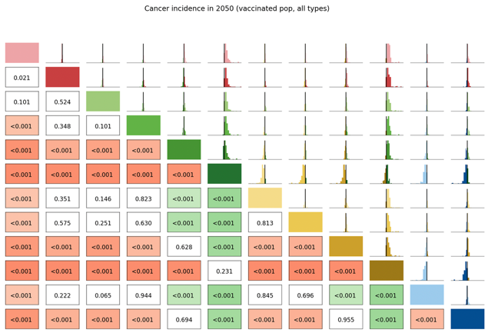

Long Term Undiagnosed Prevalence
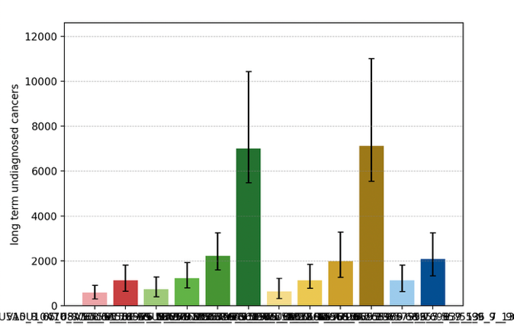
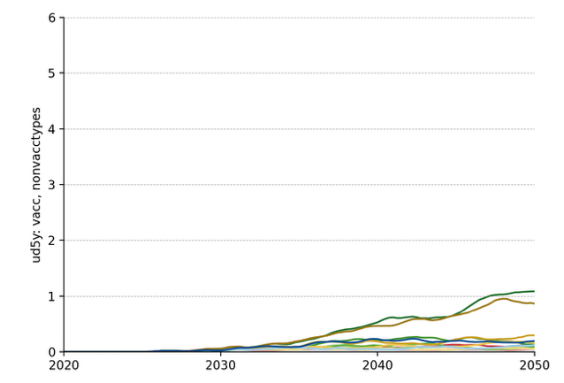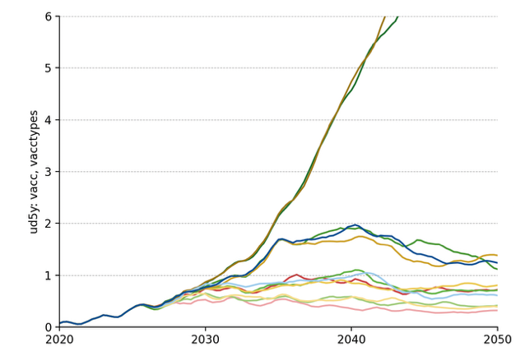
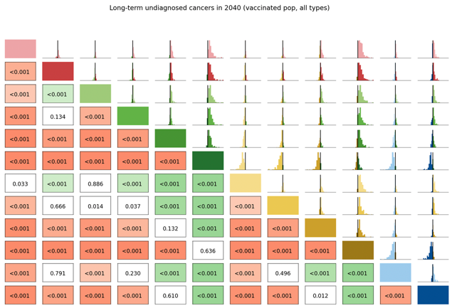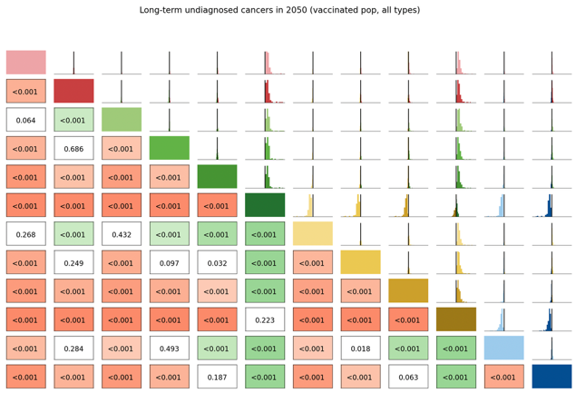

Number of Routine Screens
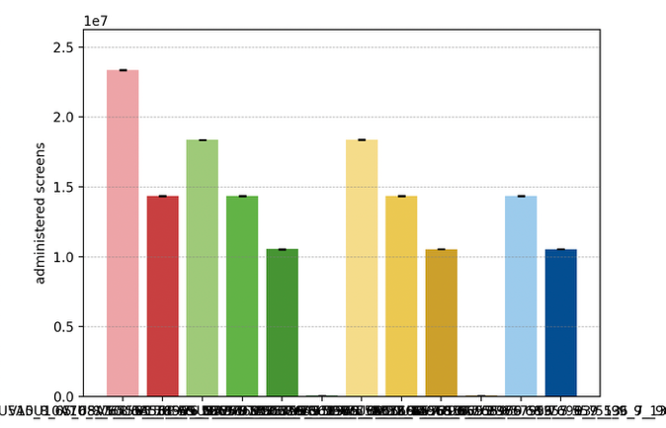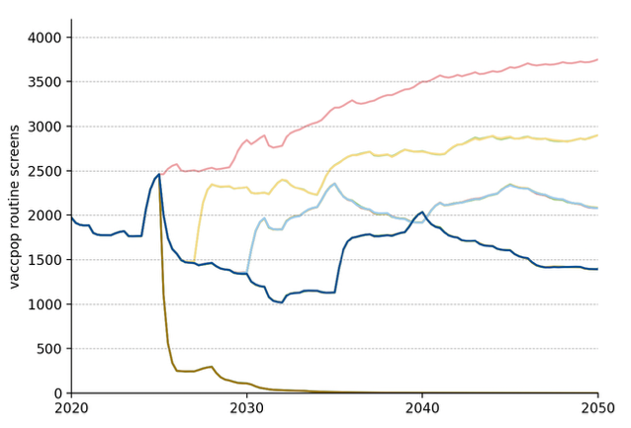

Average Number of Screens per Diagnosed Cancer, 2030-50
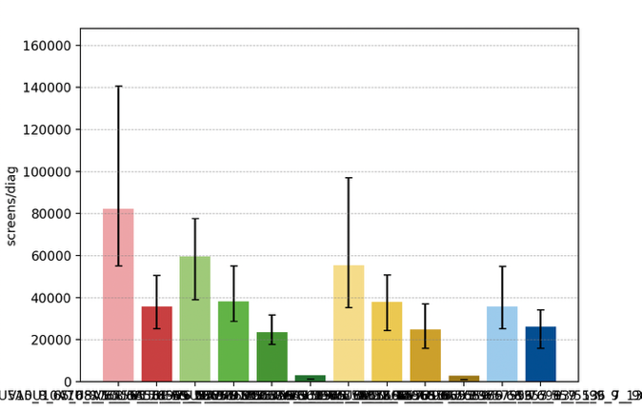

Elimination Probability Table
alg | Elimination Year: Median [LQ, UQ] (_8) | 2040.25 Elimination Probability (_8) | 2050.25 Elimination Probability (_8)
V5U5A5 | 2008 [2008, 2008] | 0.983 | 0.983
V7U5A5 | 2008 [2008, 2008] | 0.983 | 0.983
V10U5A5 | 2008 [2008, 2008] | 0.983 | 0.983
V15U5A5 | 2008 [2008, 2008] | 0.983 | 0.983
V_U5A5 | 2008 [2008, 2008] | 0.948 | 0.956
V7U7A5 | 2008 [2008, 2008] | 0.983 | 0.983
V10U10A5 | 2008 [2008, 2008] | 0.983 | 0.983
V15U15A5 | 2008 [2008, 2008] | 0.974 | 0.974
V_U_A5 | 2008 [2008, 2008] | 0.948 | 0.956
V10U7A5 | 2008 [2008, 2008] | 0.983 | 0.983
V15U10A5 | 2008 [2008, 2008] | 0.983 | 0.983
V10U10A10 | 2008 [2008, 2008] | 0.983 | 0.983
Maximum margin: 0.0381077495760359

Unvaccinated Vaccine Eligible Population projections

Cervical Cancer Incidence
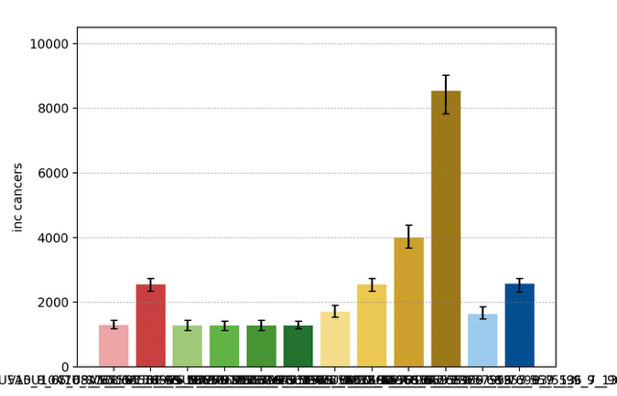
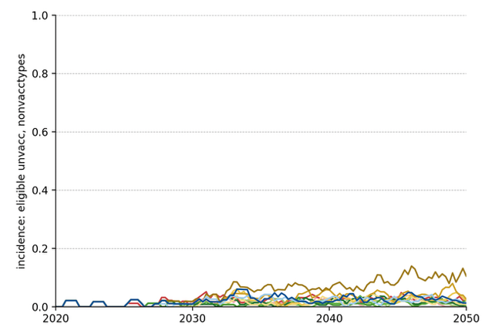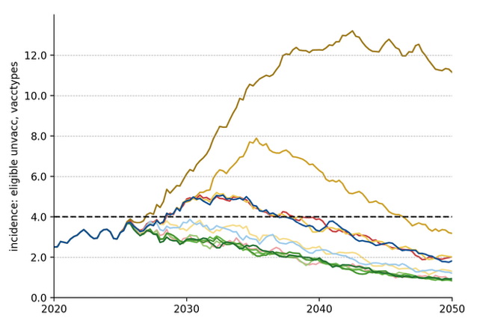
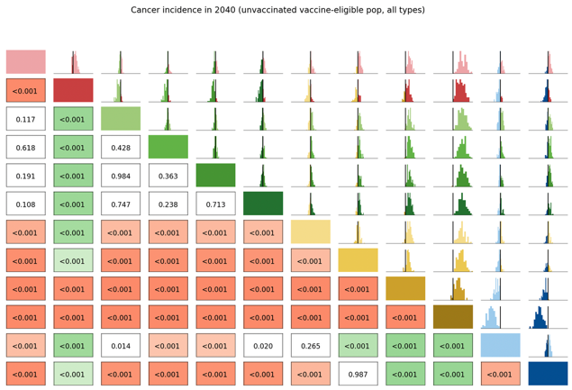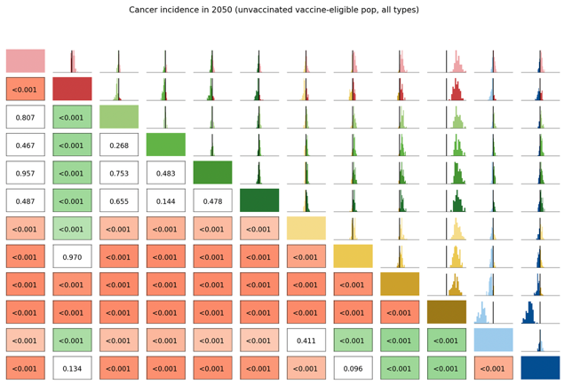

Long Term Undiagnosed Prevalence
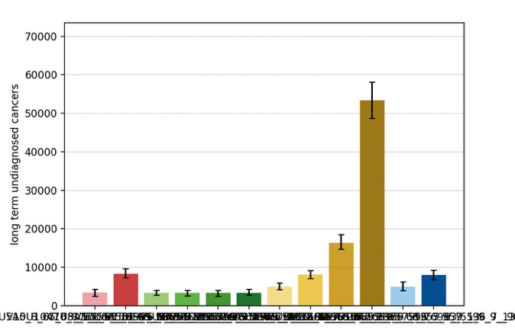
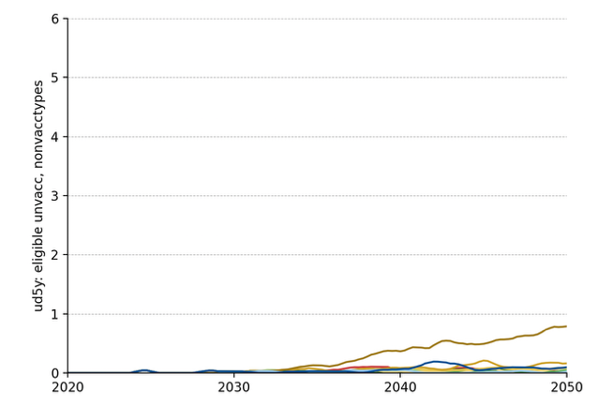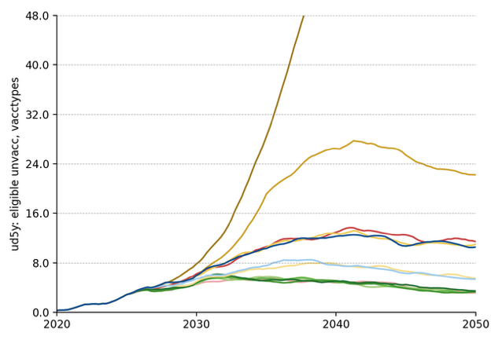
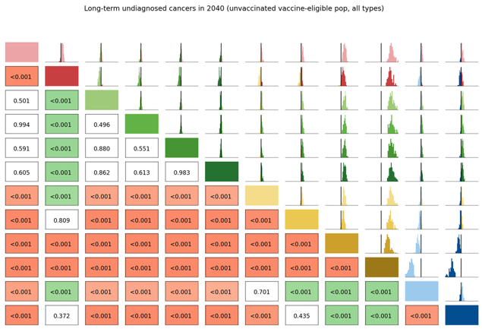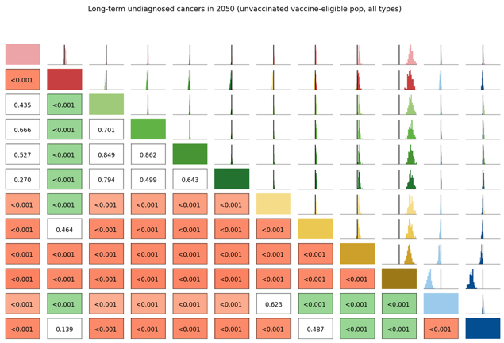

Number of Routine Screens
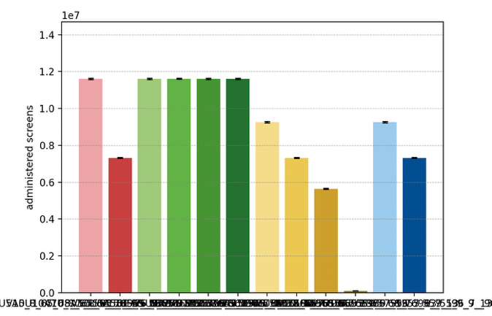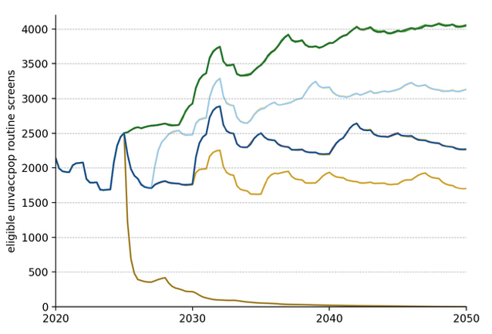

Average Number of Screens per Diagnosed Cancer, 2030-50
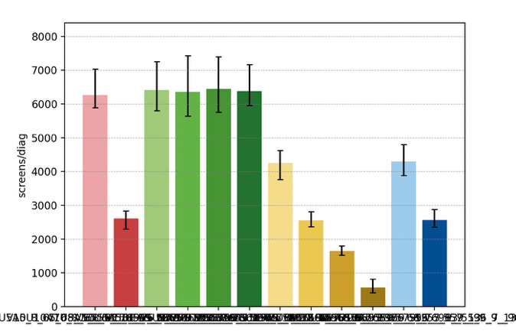

Elimination Probability Table
alg | Elimination Year: Median [LQ, UQ] (_8) | 2040.25 Elimination Probability (_8) | 2050.25 Elimination Probability (_8)
V5U5A5 | 2036 [2034, 2039] | 0.788 | 0.983
V7U5A5 | 2037 [2034, 2039] | 0.797 | 0.983
V10U5A5 | 2036 [2033, 2038] | 0.832 | 0.974
V15U5A5 | 2036 [2033, 2038] | 0.859 | 0.974
V_U5A5 | 2036 [2034, 2039] | 0.815 | 0.974
V7U7A5 | 2040 [2038, 2043] | 0.540 | 0.983
V10U10A5 | 2047 [2044, 2049] | 0.079 | 0.797
V15U15A5 | 2052 [2050, 2054] | 0.017 | 0.256
V_U_A5 | 2056 [2056, 2056] | 0.017 | 0.017
V10U7A5 | 2040 [2038, 2042] | 0.558 | 0.983
V15U10A5 | 2046 [2043, 2048] | 0.079 | 0.859
V10U10A10 | 2046 [2044, 2050] | 0.052 | 0.761
Maximum margin: 0.09194941978185803

